Busflix.in



**Busflix**

Announcement Chart

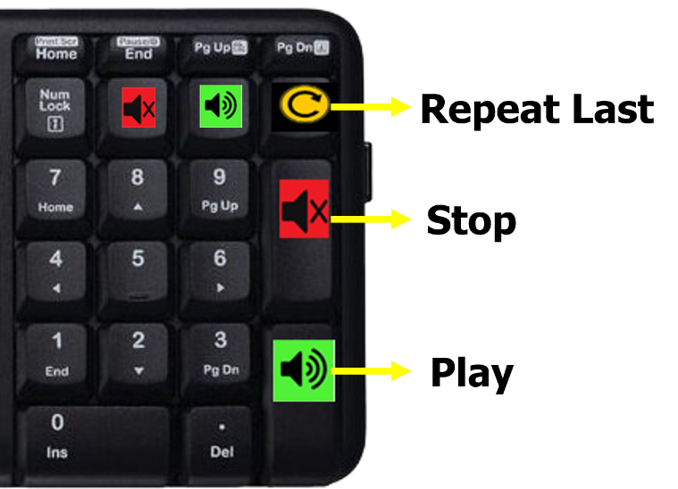



**How to use:**

**Play:** Press the correct announcement number/code and immediately press Green key on the keypad.

**Stop:** To Stop the playing announcement press Red key.

**Repeat:** To repeat the last played announcement press the yellow button.

|  |  |  |  |
| --- | --- | --- | --- |
| General | | Washroom Break | |
| **1** | Welcome | **26** | 20 min later |
| **2** | About our travels | **27** | 15 min later |
| **3** | Cleanliness rules | **28** | 10 min later |
| **4** | Busflix Entertainment | **29** | 5 min later |
| **5** | Take care of belonging | **30** | Washroom break now |
| **6** | NO dinner stop |  |  |
| **7** | Good Morning |  |  |
| Dinner | | Breakfast Break | |
| **11** | Dinner at 7 PM | **31** | 30 min later |
| **12** | Dinner at 7.30 PM | **32** | 15 min later |
| **13** | Dinner at 8 PM | **33** | 10 min later |
| **14** | Dinner at 8.30 PM | **34** | 5 min later |
| **15** | Dinner at 9 PM | **35** | Breakfast stop now |
| **16** | Dinner at 9.30 PM |  |  |
| **17** | Dinner at 10 PM |  |  |
| **18** | Dinner at 10.30 PM |  |  |
| **19** | Dinner at 11 PM |  | Your text here |
| **20** | Dinner at 11.30 PM |  |  |
| **21** | Dinner at 12 AM |  |  |
| **22** | Dinner at 12.30 AM |  |  |
| **23** | Dinner at 1 AM |  |  |
| **24** | Dinner stop NOW |  |  |

**Bangalore to Hyderabad**

|  |  |  |  |
| --- | --- | --- | --- |
| **Code** | **Dropping point** | **Code** | **Dropping point** |
| **100** | Go Tour Welcomes You To Hyderabad | **120** | Vivekananda Nagar Colony |
| **101** | Ananthapur | **121** | Kukatpally |
| **102** | Gooty | **122** | Kukatpally Metro |
| **103** | Dhone | **123** | Moosapet |
| **104** | Kurnool | **124** | Bharat Nagar |
| **105** | Jedcharla | **125** | E S I |
| **106** | Shadnagar | **126** | Erragadda |
| **107** | Shamshabad | **127** | S R Nagar (Go Tour Travels) |
| **108** | Gachibowli | **128** | Ameerpet |
| **109** | B H E L | **129** | Panjagutta |
| **110** | Chandanagar | **130** | Khairatabad |
| **111** | Madinaguda | **131** | Lakdikapool |
| **112** | Kondapur | **132** | Begumpet |
| **113** | Hafeezpet | **133** | Paradise |
| **114** | Miyapur Alwin X Roads | **134** | Secunderabad |
| **115** | Miyapur | **135** | Mettuguda |
| **116** | Hydernagar | **136** | Tarnaka |
| **117** | Nizampet | **137** | Moulali |
| **118** | J N T U | **138** | E C I L |
| **119** | K P H B |  |  |
|  |  |  |  |
|  |  |  |  |

**Hyderabad to Bangalore**

|  |  |  |  |
| --- | --- | --- | --- |
| **Code** | **Dropping point** | **Code** | **Dropping point** |
| **150** | Go Tour Welcomes You To Bangalore | **165** | Tin Factory |
| **151** | Kurnool | **166** | Karthik Nagar |
| **152** | Dhone | **167** | Marathahalli (Go Tour Travels) |
| **153** | Gooty | **168** | Bellandur |
| **154** | Ananthapur | **169** | H S R Layout |
| **155** | Chikkaballapur Bypass | **170** | Silk Board |
| **156** | Devanahalli | **171** | Rupena Agrahara |
| **157** | B I A L Airport Toll Gate | **172** | Electronic City |
| **158** | Yelahanka | **173** | Veer Sandra |
| **159** | Esteem Mall | **174** | Hebbagodi |
| **160** | Hebbal | **175** | Bommasandra |
| **161** | Nagavara | **176** | Narayana Hrudayalaya |
| **162** | Hennur | **177** | Chandapura |
| **163** | Kalyan Nagar | **178** | Attibele (Go Tour Travels) |
| **164** | Ramamurthy Nagar |  |  |
|  |  |  |  |
|  |  |  |  |

**Gangavthi to Bangalore**

|  |  |  |  |
| --- | --- | --- | --- |
| **Code** | **Dropping point** | **Code** | **Dropping point** |
| **200** | Go Tour Welcomes You To Bangalore | **213** | East End Circle |
| **201** | Tumkur | **214** | B T M Layout |
| **202** | Nelamangala Toll Gate | **215** | Silk Board |
| **203** | Parle Toll Gate | **216** | Rupena Agrahara |
| **204** | 8 Th Mail | **217** | Electronic City |
| **205** | Jalahalli | **218** | Veer Sandra |
| **206** | Goraguntepalya | **219** | Hebbagodi |
| **207** | Govardhan | **220** | Bommasandra |
| **208** | Anand Rao Circle Majestic | **221** | Narayana Hrudayalaya |
| **209** | Corporation Circle | **222** | Chandapura |
| **210** | Basavanagudi | **223** | Attibele (Go Tour Travels) |
| **211** | Jaya Nagar |  |  |
| **212** | J P Nagar |  |  |
|  |  |  |  |
|  |  |  |  |
|  |  |  |  |
|  |  |  |  |
|  |  |  |  |
|  |  |  |  |
|  |  |  |  |
|  |  |  |  |
|  |  |  |  |

**Bangalore to Gangavthi**

|  |  |  |  |
| --- | --- | --- | --- |
| **Code** | **Dropping point** | **Code** | **Dropping point** |
| **250** | Go Tour Welcomes You To Hampi | **256** | Gangavati |
| **251** | Chitradurga | **257** | Sriramnagar |
| **252** | Kudligi | **258** | De sai camp |
| **253** | Hospet | **259** | Karatagi |
| **254** | Kamalapur | **260** | Gorebal |
| **255** | Hampi | **261** | Gandhinagar |
|  |  |  |  |
|  |  |  |  |
|  |  |  |  |
|  |  |  |  |
|  |  |  |  |
|  |  |  |  |
|  |  |  |  |
|  |  |  |  |
|  |  |  |  |
|  |  |  |  |
|  |  |  |  |
|  |  |  |  |
|  |  |  |  |
|  |  |  |  |
|  |  |  |  |
|  |  |  |  |

**Hyderabad to Pune**

|  |  |  |  |
| --- | --- | --- | --- |
| **Code** | **Dropping point** | **Code** | **Dropping point** |
| **300** | Go Tour Welcomes You To Pune | **313** | Railway Station |
| **301** | Solapur | **314** | Jahangir Hospital |
| **302** | Indapur | **315** | Shivaji Nagar |
| **303** | Bigwan | **316** | Aundh |
| **304** | Kurkumbh | **317** | Vishal Nagar |
| **305** | Loni Kalbhor | **318** | Jagtap Dairy Chowk |
| **306** | Hadapsar Akashwani | **319** | Hinje Wadi |
| **307** | Hadapsar Vaibhav Theater | **320** | Wakad |
| **308** | Magarpatta | **321** | Chinchwad |
| **309** | Kharadi | **322** | Nigdi |
| **310** | Chandan Nagar | **323** | Talawade |
| **311** | Viman Nagar |  |  |
| **312** | Yerwada |  |  |
|  |  |  |  |
|  |  |  |  |
|  |  |  |  |
|  |  |  |  |
|  |  |  |  |
|  |  |  |  |
|  |  |  |  |
|  |  |  |  |
|  |  |  |  |

**Pune to Hyderabad**

|  |  |  |  |
| --- | --- | --- | --- |
| **Code** | **Dropping point** | **Code** | **Dropping point** |
| **350** | Go Tour Welcomes To Hyderabad | **369** | Nizampet |
| **351** | Solapur | **370** | J N T U |
| **352** | Naldurg | **371** | K P H B |
| **353** | Omerga | **372** | Vivekananda Nagar Colony |
| **354** | Bangla | **373** | Kukatpally |
| **355** | Humnabad | **374** | Moosapet |
| **356** | Zaheerabad | **375** | Balanagar |
| **357** | Sangareddy | **376** | Bowenpally |
| **358** | Isnapur | **377** | Secunderabad |
| **359** | Patancheru | **378** | Paradise |
| **360** | R C Puram | **379** | Lakdikapool |
| **361** | Beeramguda | **380** | Khairatabad |
| **362** | Ashok Nagar | **381** | Panjagutta |
| **363** | B H E L (Lingampally) | **382** | Ameerpet |
| **364** | Chandanagar | **383** | S R Nagar (Go Tour Travels) |
| **365** | Madinaguda | **384** | Erragadda |
| **366** | Miyapur Allwyn X Roads | **385** | ESI |
| **367** | Miyapur | **386** | Bharath Nagar |
| **368** | Hydernagar |  |  |
|  |  |  |  |
|  |  |  |  |
|  |  |  |  |